face recognition SDK

FAQ

1. Q: What are the requirements for adding face database photos?

A: In order to ensure the quality of photos added to the face database, the default requirements are:

The pixels of the face frame shall not be less than 90 (this threshold value can be adjusted through the interface mipsSetPicFaceWidthThrehold), and the face deflection angle shall not exceed 15 degrees (the threshold can be adjusted through the interfaces mipsSetPicYawAngle, mipsSetPicPitchAngle, mipsSetPicRollAngle), and the light is normal (normal indoor light);

The resolution of the whole photo does not exceed 4096*2688;

2. Q: What factors are the identification distance related to?

A: The angle of the camera (under certain picture pixels, the larger the angle, the smaller the pixels occupied by people or objects in the picture, so the larger the angle, the closer the recognition distance), and the "minimum face frame for face recognition" set by the software (the larger the value, the closer the distance)

3. Q: What if "Please check whether the hardware authorization is correct" appears?

A: First, make sure that the system time is the current time and the motherboard has been welded with an encryption chip (in Settings-About "Face Recognition" in the device

If there is no problem with the above, you can use "FaceTypeChipDetectAlll.apk" to detect the model and

Whether the SDK types used are consistent or not, and finally if there are still problems, check the firmware version number to ensure that the firmware version is relatively new (firmware after May 2019).

4. Q: What if "Please check whether the authorization file is correct" appears?

A: Use "FaceTypeChipDetectAll.apk" to check whether it has been pre-authorized (inMac: pre-authorized, outMac: not pre-authorized). If it is not pre-authorized, please export the equipment information and send it to relevant business personnel (see relevant API documentation for specific steps).

5. Q: Why is there already a face frame and there is no VIP identification information?

A: Generally speaking, face recognition has higher requirements for face state than face tracking, which is mainly reflected in the size and angle of the face.

Degree, face motion state (parameters can be set through the following interface:
MipsSetVIPDetectFaceWidthThrehold, mipsSetVIPRollAngleThrehold, mipsSetVIPYawAngleThrehold, mipsSetVIPPitchAngleThrehold)

6. Q: Why does restarting the board Demo or the preview picture of the binocular camera in the application change from color to black and white?

A: When the board is connected to the binocular camera, one will be defined as the rear camera and the other as the front camera, which will be recognized first.

The image head is a rear shot and the rear recognition is a front shot. When the board is started, the camera that scans the infrared first will define it as a rear shot. In Demo/application, the rear camera will be used as the preview picture by default, so the preview picture will change from color to black and white. When this kind of feeling

When the situation occurs, two temporary solutions (1) can be solved by replacing the USB interface cables of the binocular camera with each other and restarting them; (2) Adjust by setting the front and rear camera, open "Settings-> Other Settings-> Camera Adjustment", set Camera 0 to the front camera in the dialog box,

Camera 1 is set to rear camera, and click the Exit button to exit the dialog box and restart the board. The PID and VID numbers of the recommended binocular USB camera will be adapted in the subsequent firmware update, so that the color camera is fixed as the rear camera and the infrared camera is the front camera. When a customer has a new double-eye USB camera,

Purpose

When the USB camera needs to be debugged, we re-adapt it (firmware is solidified or users can customize the front and rear shots through configuration files).

7. Q: How to detect and improve the recognition rate when wearing a mask?

A:

- Can only be used on SenseTime 2.0 algorithm;

- The attribute recognition function needs to be turned on (mipsEnableFaceAttr() is called), and mipsFaceInfoTrack is detected during recognition. After flgSetAttr is 1, read the isMask label bit, 1: wearing a mask, 0: not wearing a mask;

- Since my similarity will decrease when wearing a mask, it is necessary to reduce the similarity threshold after detecting wearing a mask. This threshold can be adjusted by using mipsSetSimilarityThreholdMask (SenseTime IDCheck V2 is set to: 0.7) and 0.8 by using the algorithm of "SenseTime IDCheck V3.5. 4". There is no detection inside SDK that wearing a mask will use the normal similarity threshold.

- When wearing a mask, the face quality will decline, and mipsSetFaceScoreThrehold () is required.

And mipsSetFaceScoreThreholdVIP() sets the face detection score threshold, and it is recommended to set it to 0.1 first.

- When wearing a mask, the success rate of identification will decrease, and the VIP refresh function needs to be turned on (mipsEnableRefreshFaceVIP() is called). The default refresh time is 10 times (mipsSetMaxVipVerifyCntThrehold () can be adjusted);

- Reference Scene Settings for Configuration of Common Scene Parameters:

mfaceTrackLiveness.mipsSetSimilarityThrehold (0.8 f);

mfaceTrackLiveness.mipsSetFaceWidthThrehold (120);

mfaceTrackLiveness.mipsEnableRefreshFaceRect ();

mfaceTrackLiveness.initFaceDB (context, VIP_DB_PATH + "mipsVipFaceDB", VIP_DB_PATH + "image", 1); mfaceTrackLiveness.mipsEnableVipFaceVerify ();
mfaceTrackLiveness.mipsEnableIDFeatureCropFace();
mfaceTrackLiveness.mipsSetIDProCropFaceBorderwidth(50);
mfaceTrackLiveness.mipsSetFaceScoreThreholdVIP(0.1 f); mfaceTrackLiveness.mipsSetFaceScoreThrehold (0.1 f);

mfaceTrackLiveness.mipsSetMaxFaceTrackCnt (2);
if (mfaceTrackLiveness.mipsGetAlgorithmInfo (). equals ("SenseTime IDCheck V2")) {

mfaceTrackLiveness.mipsSetSimilarityThreholdMask (0.7 f);

}

else if (mfaceTrackLiveness.mipsGetAlgorithmInfo (). equals ("SenseTime IDCheck V3.5. 4"))

{

mfaceTrackLiveness.mipsSetSimilarityThreholdMask (0.8 f); mfaceTrackLiveness.mipsSetLivenessMode (0);
}

8. Q: When the face feature database is abnormal, how to restore the face feature database?

A: The face feature database is not saved in the algorithm upgrade or accidental power failure database, resulting in inconsistent personnel information stored in the business database and the face feature database. It is necessary to re-extract the face and put it into storage. It is recommended to maintain the face feature database by adopting the following process:

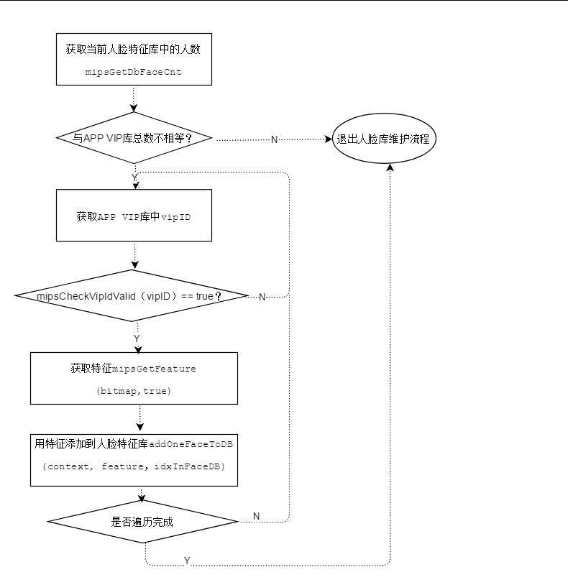
Iteration complete?
Add feature to the database
Get face features data
Exit the Face database process
Get vipID(person id) in App
Check number with App stored number?
Get total Face number of registered user

